Lab: Defining Classes

Bank Account
Create a class named BankAccount.
The class should have private fields for:
id: int
balance: decimal
The class should also have public properties for:
Id: int
Balance: decimal
You should be able to use the class like this:
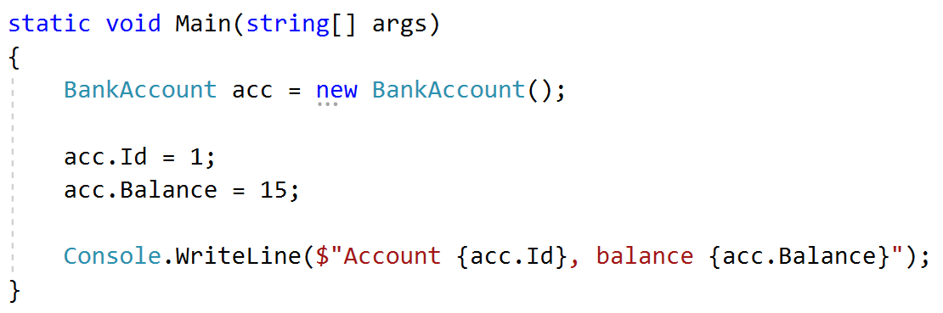
Solution
Create a new class and ensure proper naming
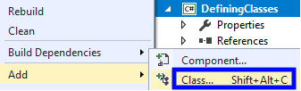

Bank Account Methods
Create a class BankAccount (you can use class from previous task)
The class should have private fields for:
id: int
balance: decimal
The class should also have properties for:
Id: int
Balance: decimal
Deposit(decimal amount): void
Withdraw(decimal amount): void
Override the method ToString().
You should be able to use the class like this:
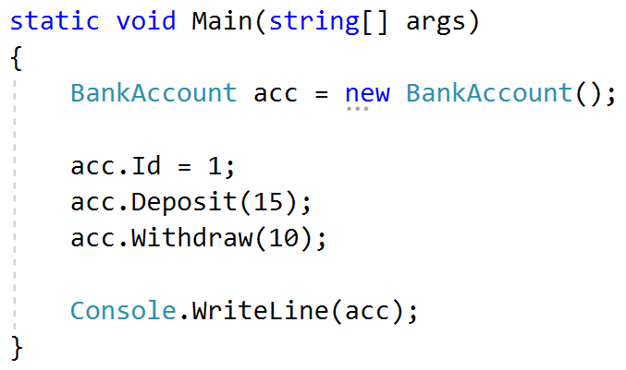
Solution
Create a method Deposit(decimal amount)
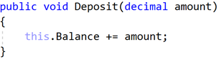
Create a method Withdraw(decimal amount)
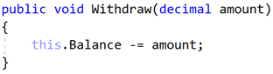
Override the method ToString()
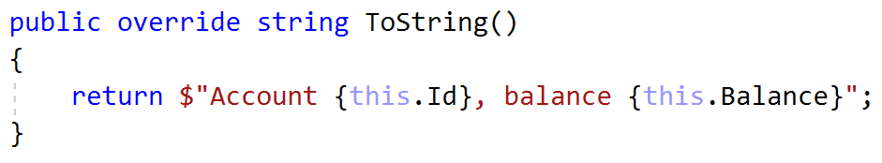

Test Client
Create a test client that tests your BankAccount class.
Support the following commands:
Create {Id}
Deposit {Id} {amount}
Withdraw {Id} {amount}
Print {Id}
End
If you try to create an account with an existing Id, print "Account already exists".
If you try to perform an operation on a non-existing account, print "Account does not exist".
If you try to withdraw an amount larger than the balance, print "Insufficient balance".
The Print command should print "Account ID{id}, balance {balance}". Round the balance to the second digit after the decimal separator.
Examples
Input | Output
Create 1  Create 1  Deposit 1 20  Withdraw 1 30  Withdraw 1 10  Print 1  End | Account already exists  Insufficient balance  Account ID1, balance 10.00
Deposit 2 20  Withdraw 2 30  Print 2  End | Account does not exist  Account does not exist  Account does not exist
Solution
Create a Dictionary<int, BankAccount> to store existing accounts
Create the input loop:
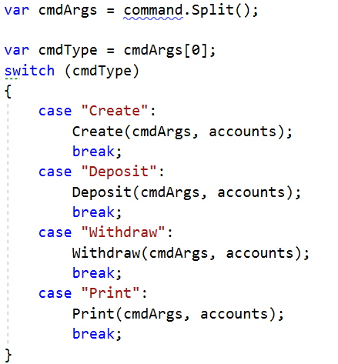
Check the type of command and execute accordingly (optional: you can create a separate method for each command)
Implement the Create command:
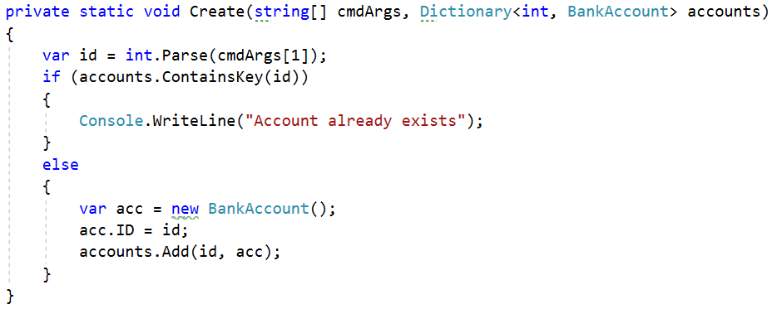
Implement the rest of the commands following the same logic.

Person Class
Create a Person class.
The class should have private fields for:
name: string
age: int
accounts: List<BankAccount>
The class should have constructors:
Person(string name, int age)
Person(string name, int age, List<BankAccount> accounts)
The class should also have public methods for:
GetBalance(): decimal
Solution
Create the class as usual:
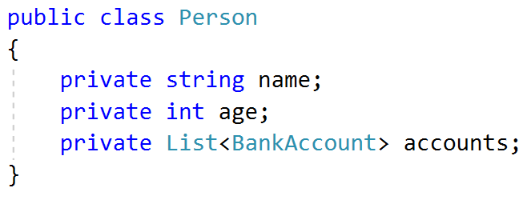
Create a constructor with two parameters:
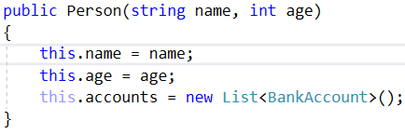
Create a constructor with three parameters:
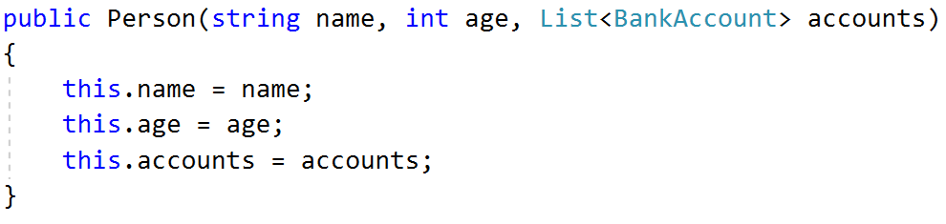
Create method GetBalance():
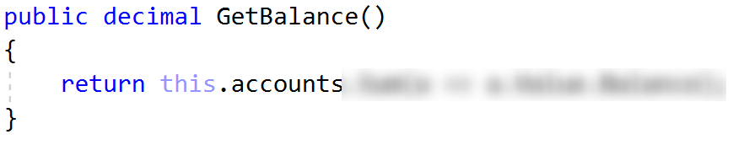
Optional: You can take advantage of constructor chaining:
